**SOLANO COMMUNITY COLLEGE**

**MT 162, ROBOTICS**

Fall, 2018

SOLANO COMMUNITY COLLEGE

ROBOTIC SYSTEMS MT-162

**LAB 2: TOOL FRAMES**

**Catharine Crayne**

**9/18/18**

**OBJECTIVE**:

1. To learn how to setup a Tool Frame, test TCP, and Jog in a Tool Frame

**Group Members**

Diane (originally we planned on doing Lab 3 work, and accidentally did Lab 2 work together before moving on to Lab 3)

**MATERIALS**: Ruler or measuring tape, RoboGuide and Laptop, Fanuc Robot

**PROCEDURE**:

1. Power up the robot controller. Place the robot in Teach Mode.
2. Turn on Teach Pendant and change the robot’s jog speed to 25%. Set the robot to jog in the WORLD coordinate system.
3. Hold [SHIFT] + [COORD] on the teach pendant. The Jog Menu should appear. Note what appears in the Yellow Jog Menu.
4. If USER is not 0, cursor to USER and enter 0. This sets the USER frame to the WORLD frame.
5. If TOOL is not 2, cursor to TOOL and enter 2 on the keypad. This sets the TOOL frame to an uninitialized tool frame.
6. Set the [COORD] to WORLD and jog the robot using X,Y, Z, W, P, R. Notice how it moves in each of these directions.
7. Now set the [COORD] to TOOL and jog the robot using X,Y, Z, W, P, R. Notice how it moves in these directions. How are they different?
8. Follow the Procedure 8-1 on the handout and define a Tool Frame (#2) using the 3 point method.
9. Press the [SHIFT] + [COORD] keys to make sure you have selected Tool Frame 2. Jog the robot in the X, Y, and Z directions. How these directions different than those in step 7?
10. Now jog the robot in the W, P, R directions. How does this compare to the directions in Step 7? How do you know if this Tool Frame’s TCP is valid?
11. Now follow Procedure 8-2 on the handout and define a Tool Frame (#3) using the Direct Entry Method.
12. Now go back into the Frames Setup Menu again, verify you are in the Tool Frame setup menu; if you aren’t in that menu, select OTHER. Clear the entries for Tool Frames (#2) and (#3).

**Results – Data**

Step 3: The drop-down menu includes Tool (.=10), Jog and User Frame Selection numbers.

Step 6/7: In world mode, the point of reference is at the intersection of J1/J2. In TOOL, the point of reference for movement is at the faceplate on J6.

Step 9: The point of reference for movement of the robot is now based around the tip of the tool.

Step 10: The robot rotates around the point we programmed. We know the TCP is correct because it remains stationary during the rotational moves of Yaw, Pitch, and Roll.

**Observations**

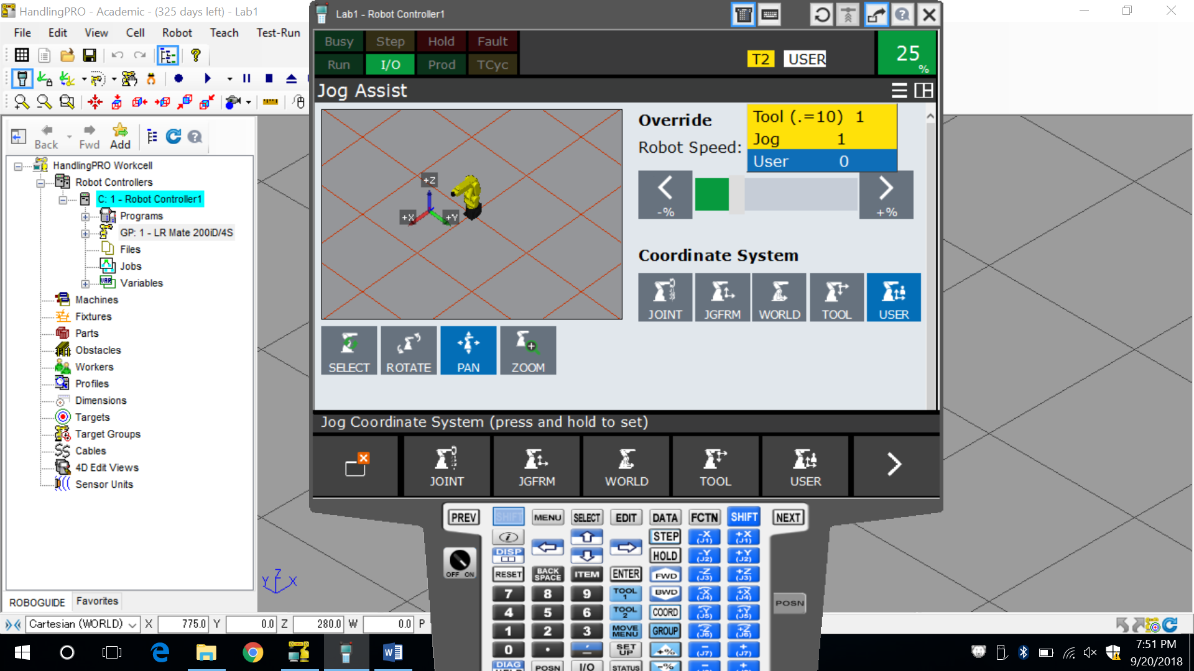 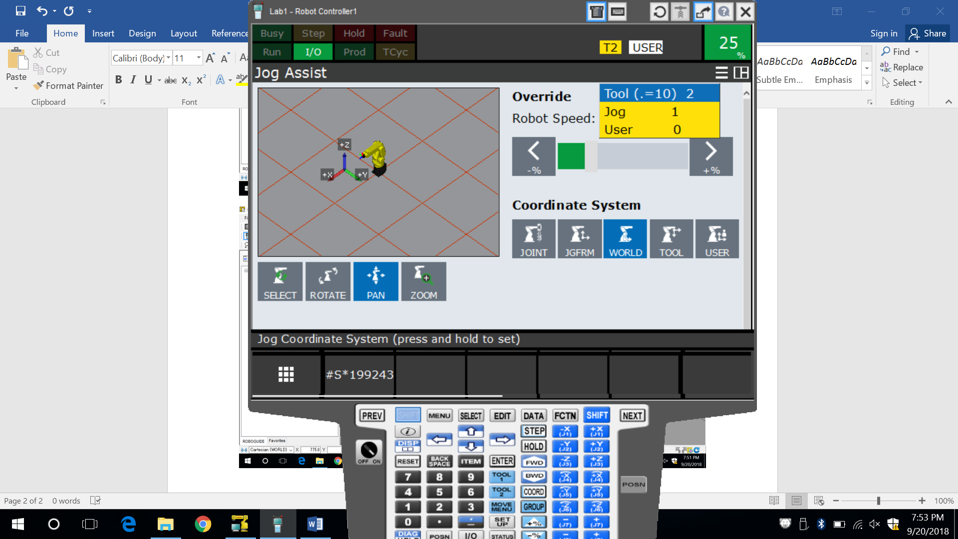 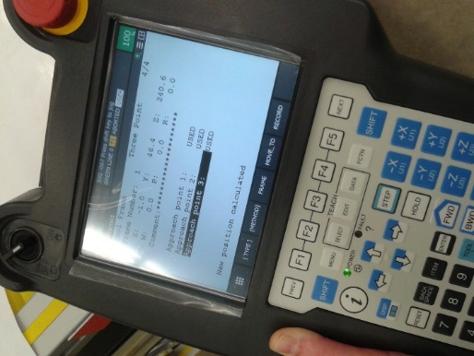 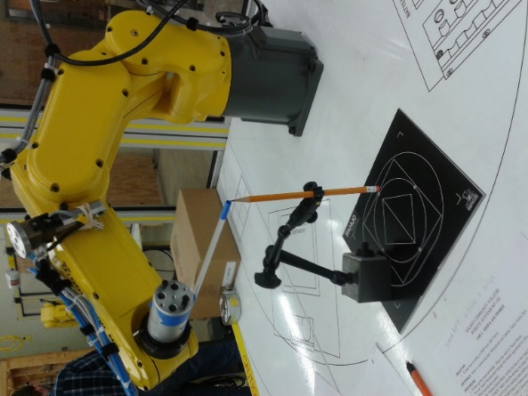

**Analysis Questions:**

1. Where is the default TOOL center point?

*Faceplate on J6*

1. What KEYs must be pressed to display frame the JOG menu?

*[SHIFT] + [COORD]*

1. Besides the 3 Point and Direct Entry methods, what other methods can be used to teach a TOOL frame?

*6 Point Method*

1. Why would different Tool Frames be needed on an industrial robot?

*You would need different Tool Frames if you have more than one tool, or your tool has more than one point.*